Post-Questionnaire Reflection

Values Ranking
- What did you learn about your values? Group similar words into values or value clusters (i.e. values similar to each other) into the grid below. Don't get hung up on the choice of words. Try your best to create a list of 5. Write down the 5 values (or value clusters) identified in column 1 of the table below.
Value (Cluster) | Priority ranking  (1-5, 1 most important) | How present in your last job (0-10, 10 highest)

- In column 2 of the table above, prioritize your values based on how important they are to you. Don’t try to get a perfect answer as it may not exist and may change. It’s the process of prioritization that matters.
- Circle your top 3 values
- Reflect on you’re your life, or an area of your life that you’d like to focus on. In column 3 of the table, rate how much each of your values were honoured from 0-10, 10 being the highest. What comes up?
- Next, shift your attention to the career you’d like to embark on next. Based on how important each of your top 3 values and the other work-related values below are for you, rate each of them from a scale of 1-5, 5 being the most important.

Criteria | Rating
Value #1:
Value #2:
Value #3:
Prestige of employer
Career progression
Physical work environment
Compensation
Leading others
Work-life balance
Flexibility
Meaningful work
Professional development
Collaboration
Autonomy
Innovation
Other:

The Competing Values Framework

When you know a bit more about your values, use the framework below to explore what type of organizations may fit you better.
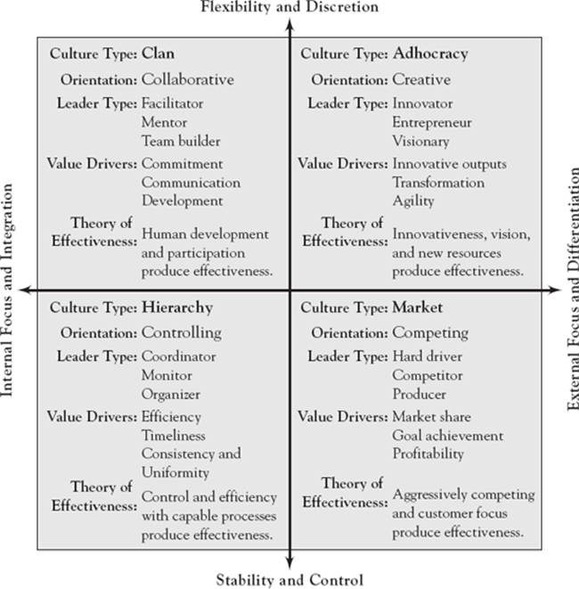

Source: Cameron, K. S., & Quinn, R. E. (2011). Diagnosing and changing organizational culture: Based on the competing values framework. John Wiley & Sons.

How do all these insights about yourself so far contribute to your career decisions?

Industries

Functional areas (e.g. marketing, operations, research)

Personal brand

Action plan

